**EXPERIMENT 6**

Write a C program that takes, as a command line argument, the number of megabytes of memory it will use and during execution it should consume that much memory. Observe memory usage during program execution using free command.

Before executing C file

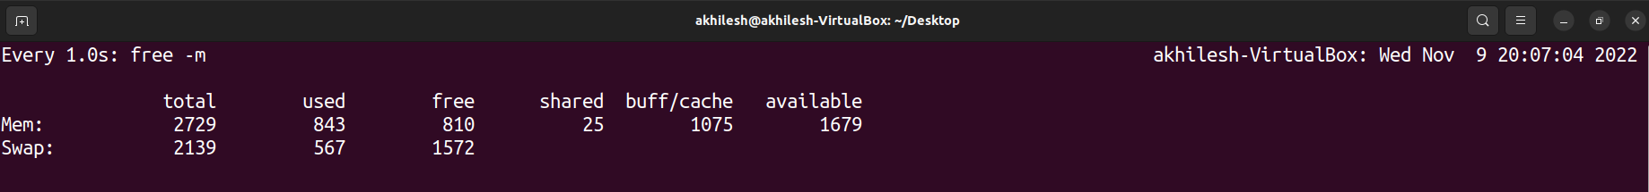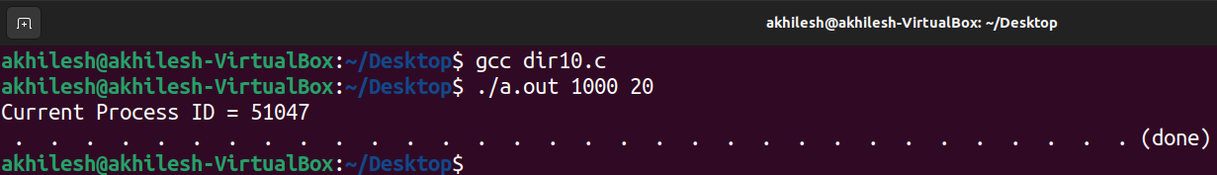

After executing C file

